**Columns**

Columns also called as attributes

Degree - Collections of columns is degree

domain = column name

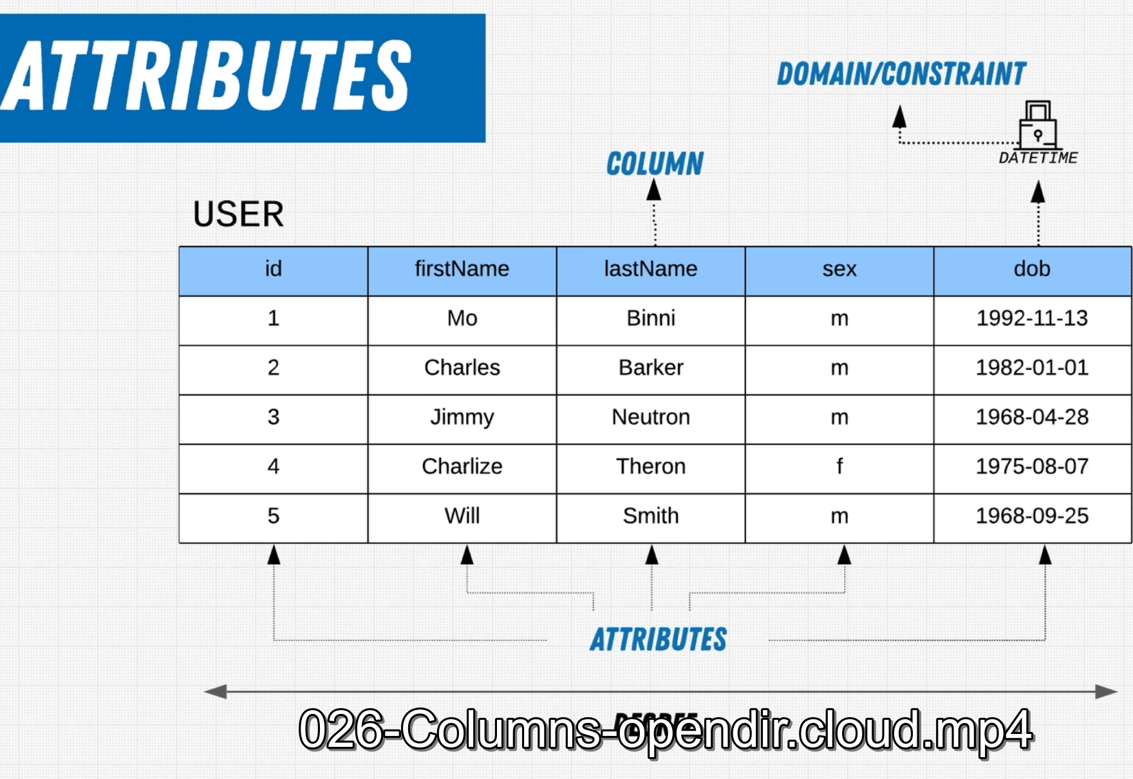

**Rows**

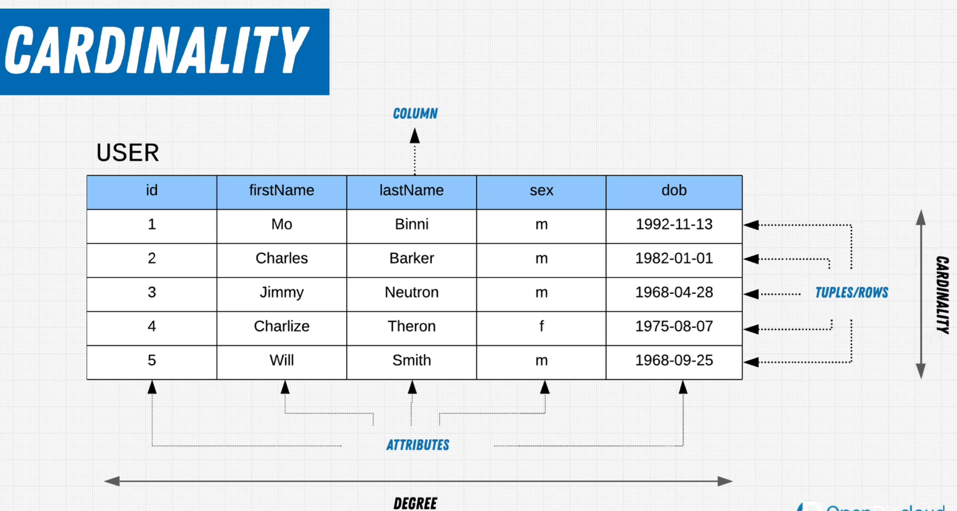

Rows also called as tuples in SQL

Cardinality : Collection of rows or tuples

OLTP vs OLAP

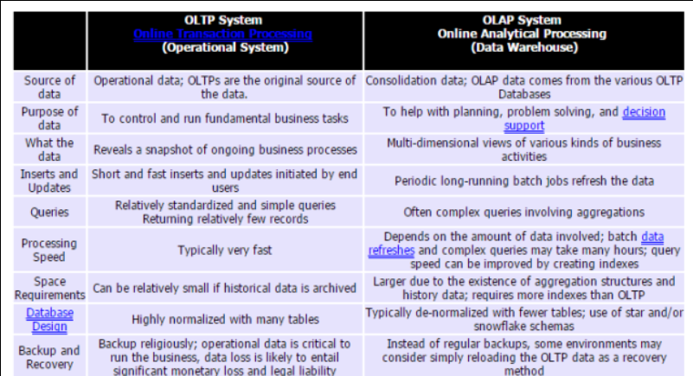

SQL COMMANDS

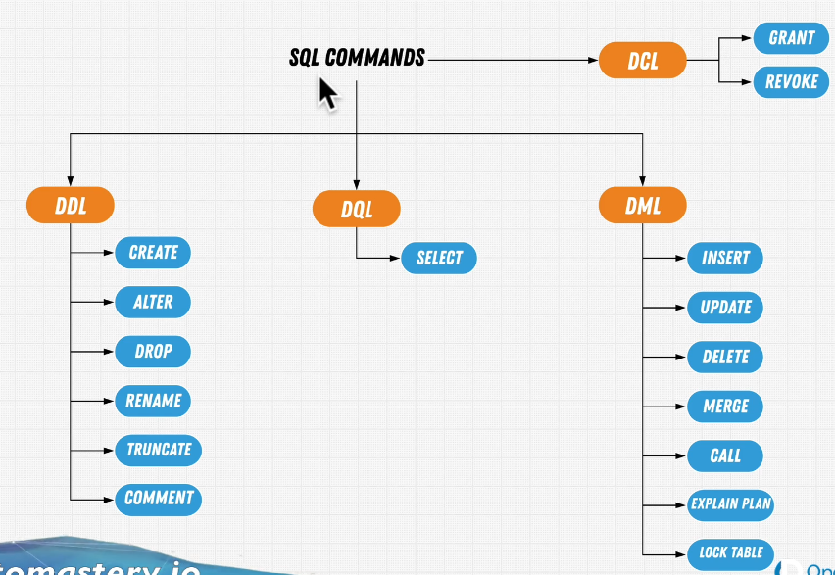

Operation Precedence

